Sail Plan
Pentagon Sailing Club
Memorial Day Raft Up 2017
27 – 29 May 2017

References:

NOAA Charts
12278 Chesapeake Bay Approaches to Baltimore Harbor; 1:40,000
12281 Baltimore Harbor; 1:15,000
12282 Chesapeake Bay, Severn & Magothy Rivers, 1:25,000
12266 Chesapeake Bay – Chesapeake – Choptank and Herring Bay; 1:40,000
12280 Chesapeake Bay – 1:200,000

PSC Raft-up Guidelines

Under the “Raft Up” link on the PSC Website

Saturday, 27 May 17: Sail from Port Annapolis up the Magothy River to raft overnight in Swan Cove between North Ferry Point and Pea Patch Pt. Raft up Saturday night. Distance from Port Annapolis to the raft up location is approximately 18.3 nm.

Sunday, 28 May 2017: Sail from the raft up location via the Craighill, Brewerton, Ft. McHenry, East, and West Channels to the Inner Harbor Marina on the Patapsco River, Baltimore, MD. Distance from raft up location is approximately 23.2 nm. The dinner party will be held at 6:30pm at the Tir Na Nog Irish Bar & Grill just off of the starboard-quarter of the U.S.S. Constellation.

Monday, 29 May 2017: Sail back to respective points of origin.

NAVIGATION

Note 1: Assume a speed 5kt SOG for projected times.

Note 2: Outside of Baltimore Harbor, recommend traveling just outside the main shipping channels to avoid commercial shipping.

Note 3: Recommend arriving at the raft up location by 4:30 PM to allow time to secure all boats before sundown.

WARNING: Small-craft operators are advised to use caution in the vicinity of Seven Foot Knoll Light as lager vessels have generated up to 12ft waves when they transited the adjacent channels.

Daily Tide Prediction: Annapolis MD
27 May 2017 07:18 AM – 01:52 PM

Station Name: Annapolis, MD Station ID: 8575512
Height Offset Low: N/A Height Offset High: N/A
Time Offset Low: N/A Time Offset High: N/A
Prediction Type: Harmonic Datum: MLLW
Interval Type: High/Low Tide Predictions

Date Day Time (EST) Pred. High/Low
27 May 17 Sat 07:14 AM 1.87ft H
27 May 17 Sat 01:52 PM 0.34ft L

Daily Tide Prediction: Magothy River
27 May 2017 03:48 PM – 28 May 2017 04:41 PM

Station Name: Mountain Point, Magothy River Station ID: 8575229
Referenced Station Name: Baltimore Reference Station Id: Baltimore 8574680
Height Offset Low: *0.77 Height Offset High: * 0.74
Time Offset Low: -4 Time Offset High: -4
Prediction Type: Subordinate Datum: MLLW

Date Day Time (EST) Pred. High/Low
27 May 17 Sat 03:48 PM 0.21ft L
27 May 17 Sat 08:52 PM 0.95ft H
28 May 17 Sun 02:39 AM 0.18ft L
28 May 17 Sun 09:17 AM 1.55ft H
28 May 17 Sun 04:41 PM 0.22ft L

Daily Tide Prediction: Baltimore Harbor
28 May 2017 09:21 AM – 29 May 2017 10:15 AM

Station Name: BALTIMORE, Fort McHenry Station ID: 8574680
Height Offset Low: N/A Height Offset High: N/A
Time Offset Low: N/A Time Offset High: N/A
Prediction Type: Harmonic Datum: MLLW
Interval Type: High/Low Tide Predictions

Date Day Time (EST) Pred. High/Low
28 May 17 Sun 09:21 AM 2.09ft H
28 May 17 Sun 04:45 PM 0.29ft L
28 May 17 Sun 09:53 PM 1.31ft H
29 May 17 Mon 03:44 AM 0.30ft L
29 May 17 Mon 10:15 AM 1.99ft H

Daily Tide Prediction: Annapolis MD
29 May 2017 03:37 PM – 09:20 PM

Station Name: Annapolis, MD Station ID: 8575512
Height Offset Low: N/A Height Offset High: N/A
Time Offset Low: N/A Time Offset High: N/A
Prediction Type: Harmonic Datum: MLLW
Interval Type: High/Low Tide Predictions

Date Day Time (EST) Pred. High/Low
29 May 17 Mon 03:37 PM 0.34 L
29 May 17 Mon 09:20 PM 1.14 H

Expected Weather

Saturday, 27 May 2017
TBA
Sunrise: 5:45 AM Sunset: 8:23 PM

Sunday, 28 May 2017
TBA
Sunrise: 5:45 AM Sunset: 8:24 PM

TBA
Sunrise: 5:44 AM Sunset: 8:24 PM

Saturday, 27 May: Port Annapolis to the Raft Up on the Magothy River

Navigation Point | ETD/ETA | Nav. Reference at WP | Course to Next WP (mag) | Distance to Next WP | Time to Next WP
Port Annapolis Marina | 09:30 or at Skipper's discretion |  | Follow channel, pass green day marker “7” (Q G 15ft 3M "3") until it is off the starboard beam. | 0.8nm | 10 min
WP 1 | 09:40 | Yellow buoy "A" (FL Y 2.5s 15ft 5M "90") | 096 | 3.2 nm | 32 min
WP 2 | 10:18 | Red buoy "90" (R "90" R 2.5s) | 023 | 1.2 nm | 12 min
WP 3 | 10:32 | First span of William P. Lane Jr. Bridge | 028 | 1.5 nm | 15 min
WP 4 | 10:42 | Red buoy "2" (R "2 QR) Follow Craighill Channel | 353 | 4.4 nm | 44 min
WP 5 | 11:26 | Red buoy "4" (R "4" FL R 4s) | 307 | 2.6 nm | 26 min
WP 6 | 11:52 | Red day marker "2" (FL R 4s 15ft 3M "2") | Follow day markers up Magothy River | 4 nm | 40 min
WP 7 | 12:32 | Red day marker "12" (FL R 4s 15ft 4M "13) (marks shoals off North Ferry Point) | Round point to starboard to head into raft up anchorage | 0.4 nm | 4 min
Raft Up Anchorage | 12:36 | 39 04 55.00 N / 076 30 14.00 E
Totals |  |  |  | 18.3 nm | 183 min

Map Graphic: MDRU Anchorages, Magothy River

1
2
3

Primary Anchorage (1): Swan Cove between Pea Patch Point and North Ferry Point
39° 04’ 55.00” N/076° 30’ 22.00” W
MLW: 14-15ft / Bottom: Soft Mud

Secondary Anchorage (2): Swan Cove between Ross Cove and Pea Patch Point (the next cove NW of Pea Patch Point)
39° 05' 08.06"N / 76° 30' 46.48"W
MLW: 14-15ft / Bottom: Soft Mud

Protected Anchorage (3): Deep Creek
500yd NW of Day Beacon 16
39° 05’ 36.00” N / 076° 31’ 50.00” W
MLW: 10ft / Bottom: Soft Mud

Sunday, 29 September: Magothy River to Inner Harbor Marina, Baltimore MD

Navigation Point | ETD/ETA | Nav. Reference at WP | Course to Next WP (mag) | Distance to Next WP | Time to Next WP
Raft Up Anchorage | 09:30 or at Skipper's discretion |  | Follow channel SE, to green lighted marker “3” (FL G 4s 18ft 4M "3") | 3.1 nm | 31 min
WP 1 | 10:01 | Green lighted marker “3” (FL G 4s 18ft 4M "3") | 83 | 2.1 nm | 21 min
WP 2 | 10:22 | Red buoy "8" (R "8" Q R) Follow Craighill Channel NNW | 10 | 3.6 nm | 36 min
WP 3 | 10:58 | Red buoy "18" (R "18" Q R) | 330 | 3.7 nm | 37 min
WP 4 | 11:35 | Red buoy "2B" (R "2B" QR) Follow Brewerton Channel WNW up Patapsco River | 302 | 3.5 nm | 35 min
WP 5 | 12:10 | Red buoy "14" (R "14" QR) Follow Ft. McHenry Channel NW | 332 | 5.0 nm | 50 min
WP 6 | 13:00 | Green buoy "3" (G "3" Q G) Follow East Channel N | 357 | 0.65 nm | 6 min
WP 7 | 13:06 | Green buoy "7" (G "7" Q G) Follow West Channel NW | 324 | 0.75 nm | 8 min
WP 8 | 13:14 | F 153ft (DAY)  FR 155ft (NIGHT)  (located on Locust Point, left side of channel) | 292 | 0.30 nm | 4 min
WP 9 | 13:18 | R "2" QR | 282 | 0.20 nm | 2 min
WP 10 | 13:20 | R "4" QR | 328 | 0.45 nm | 5 min
Inner Harbor Marina | 13:25 | Rusty Scupper Restaurant (marina is on the far side of the restaurant)
Totals |  |  |  | 23.2 nm | 235 min

Map Graphic: Inner Harbor Marina

1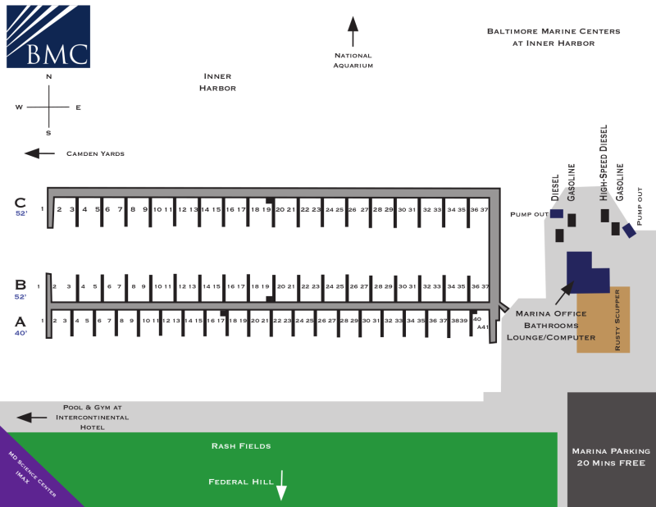

Communications

MDRU participants will a conduct communications check with the Raft Captain (call sign: TBD) via VHF channel 9 during a five minute period beginning at 2: 15 PM. All participants will repeat the communications check fifteen minutes after every subsequent hour until all PSC boats have arrived at the raft up. Upon making contact, please switch to VHF channel 71. If VHF channel 71 is busy use VHF channel 72. Otherwise use any available working channel to continue communications. Once you arrive at the raft up area, hail the “PSC Raft Captain” on VHF Channel 71.

Inner Harbor Marina – Contact the marina by VHF radio on Channel 16 or 69, via the call sign “Inner Harbor Marina.” Prepare to shift to the directed working channel. The marina manager should be on duty at the marina’s office. Phone: (410) 837-5339.

Points of Contact
Raft Captain: TBD
Raft Up Coordinator: Josh Miller (571) 327-4757, baycommodore@pentagonsailing.org

Coordinating Instructions for the Raft Up

See PSC Raft-Up Guidelines for full breakdown on how Pentagon Sailing Club conducts a raft up.

General Considerations: The largest boat should be the anchor boat, given the logic that the boat’s ground tackle is appropriately sized for the purpose. Skipper of the anchor boat ordinarily is the “raft captain” and will make decisions as necessary for safe operation given depth, tides, current, swing radius, scope of road, existing and forecasted winds, and adequacy and placement of fenders and lines.
- Unless directed otherwise by the raft captain, approach the raft from the stern of those already anchored
- Alternate sides when rafting to maintain balance on anchors.
- Prepare lines and place fenders prior to approaching the raft. Traditionally the vessel approaching the raft will deploy its own lines and fenders—this makes for a more organized breakup when departing.
- Boats and boat captains should prepare by:
  - Evaluating factors to determine anchor(s) to set for the raft.
  - Coordinating with skipper of receiving boat.
  - Briefing and positioning crew to pass lines/fend off (looped end of lines are passed to the raft).
  - Receiving vessel positions crew to receive bow lines, stern lines, forward spring line, aft spring line
  - Position a minimum of two 46 inch fenders
  - A long passing (control) line if the approaching boat is also to set an anchor
  - When positioning alongside, secure lines ensuring boat spreaders are not aligned to avoid collisions

Customs and Courtesies

As a part of the etiquette during the raft up, please consider the following:
- Move between boats via the gangway entrances near the cockpits. Use secure handholds and carefully step between neighboring boats to avoid injury to you and our member’s boats.
- Do not enter a boat’s salon unless invited below; it is the crew’s private accommodations.
- Minimize noise while topside when other crewmembers have retired for the night.
- Do not use your generator during the raft as toxic exhaust fumes can accumulate in cabins or collect at the surface of the water, thereby endanger those below decks and those who swim.

